PROJECT REPORT
1. INTRODUCTION

- Project Title : - Heritage Treasures: An In-Depth Analysis of UNESCO World Heritage Sites in Tableau

- Team members and Roles:

- Konda Prabhakar(Team lead) - Team Lead, Project Planning & Coordination

- Molla Afrid(Member) - Tableau Dashboard Development & Flask Web Integration

- Madarapu Sri Venkata Krishna - Data Collection & Data Preprocessing

- Anuradha Malleswarapu - Documentation & Testing

- Madduluri Sushma Sree - Data Analysis & Visualization Support

1.1 Project Overview
UNESCO World Heritage Sites represent humanity's most significant cultural and natural landmarks, yet information about them is scattered across spreadsheets, static reports, and text-heavy web pages. This project, "Heritage Treasures," builds an interactive Tableau dashboard suite that consolidates site distribution, geographic spread, inscription trends, and conservation risk into a single, explorable visual experience — published to Tableau Public and embedded into a custom Flask web application.

1.2 Purpose
- Help researchers and conservation bodies quickly identify heritage sites that are most at risk.
- Give students, educators, and travelers an engaging, visual way to explore world heritage data.
- Replace scattered spreadsheets and static reports with one connected, interactive dashboard suite.
- Make the analysis publicly accessible via the web, without requiring Tableau software.

2. IDEATION PHASE

2.1 Problem Statement
Two customer problem statements were defined using the "I am / I'm trying to / But / Because / Which makes me feel" format:
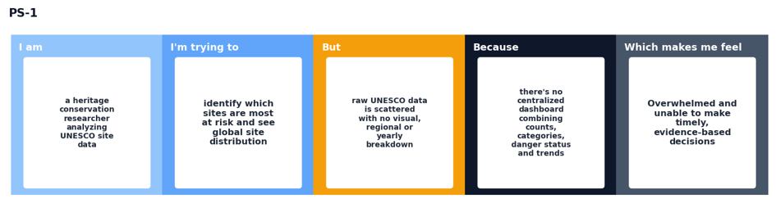
PS-1: Heritage conservation researcher
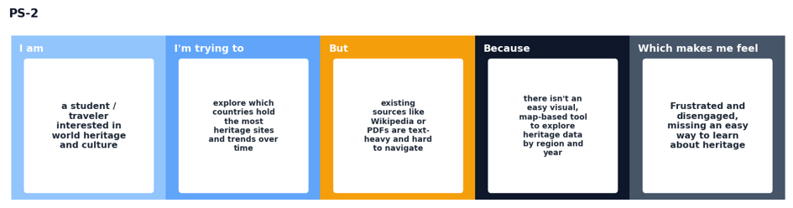
PS-2: Student / traveler interested in world heritage

2.2 Empathy Map Canvas
An empathy map was built for the primary dashboard user — a heritage data analyst — to understand their thoughts, environment, and pain points before designing the solution.

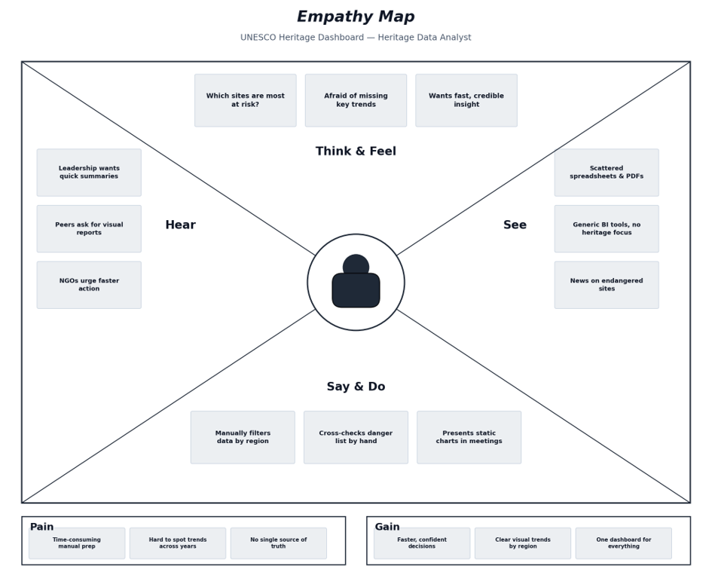
Empathy Map — Heritage Data Analyst

2.3 Brainstorming
The team brainstormed and grouped ideas into four themes: Data Sources & Preparation, Core Visualizations, Risk & Danger Analysis, and Delivery & Interactivity, then prioritized them by importance and feasibility.
Step-1: Team Gathering, Collaboration and Select the Problem Statement
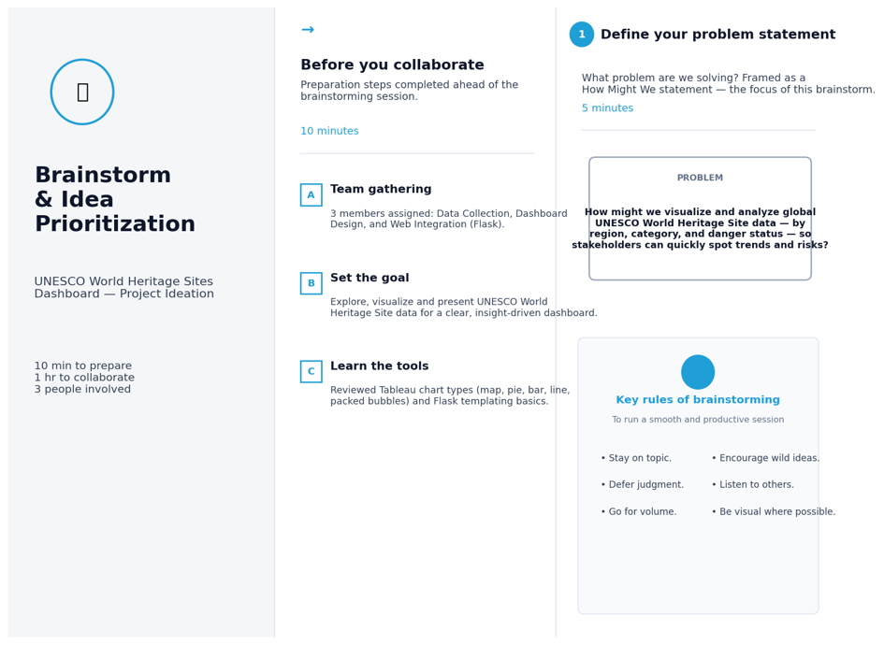

St

Step-2: Brainstorm, Idea Listing and Grouping

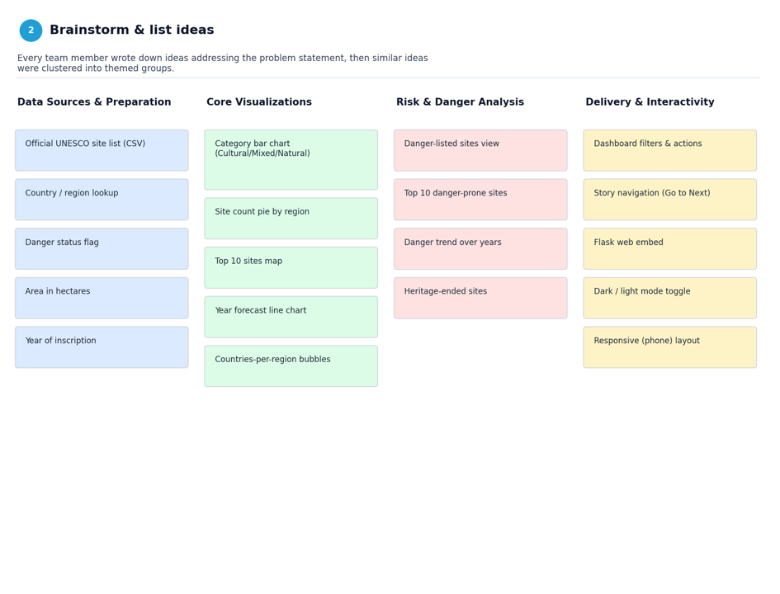

Step-3: Idea Prioritization

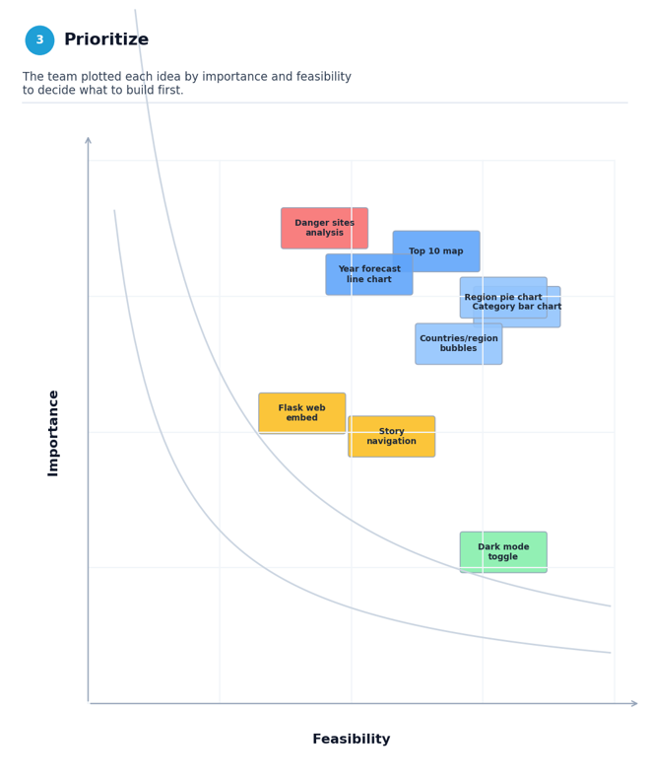

3. REQUIREMENT ANALYSIS

3.1 Customer Journey Map
The journey map traces a Dashboard User / Analyst discovering, exploring, and sharing the UNESCO dashboard, from first hearing about it (Entice) through to revisiting it later (Extend).
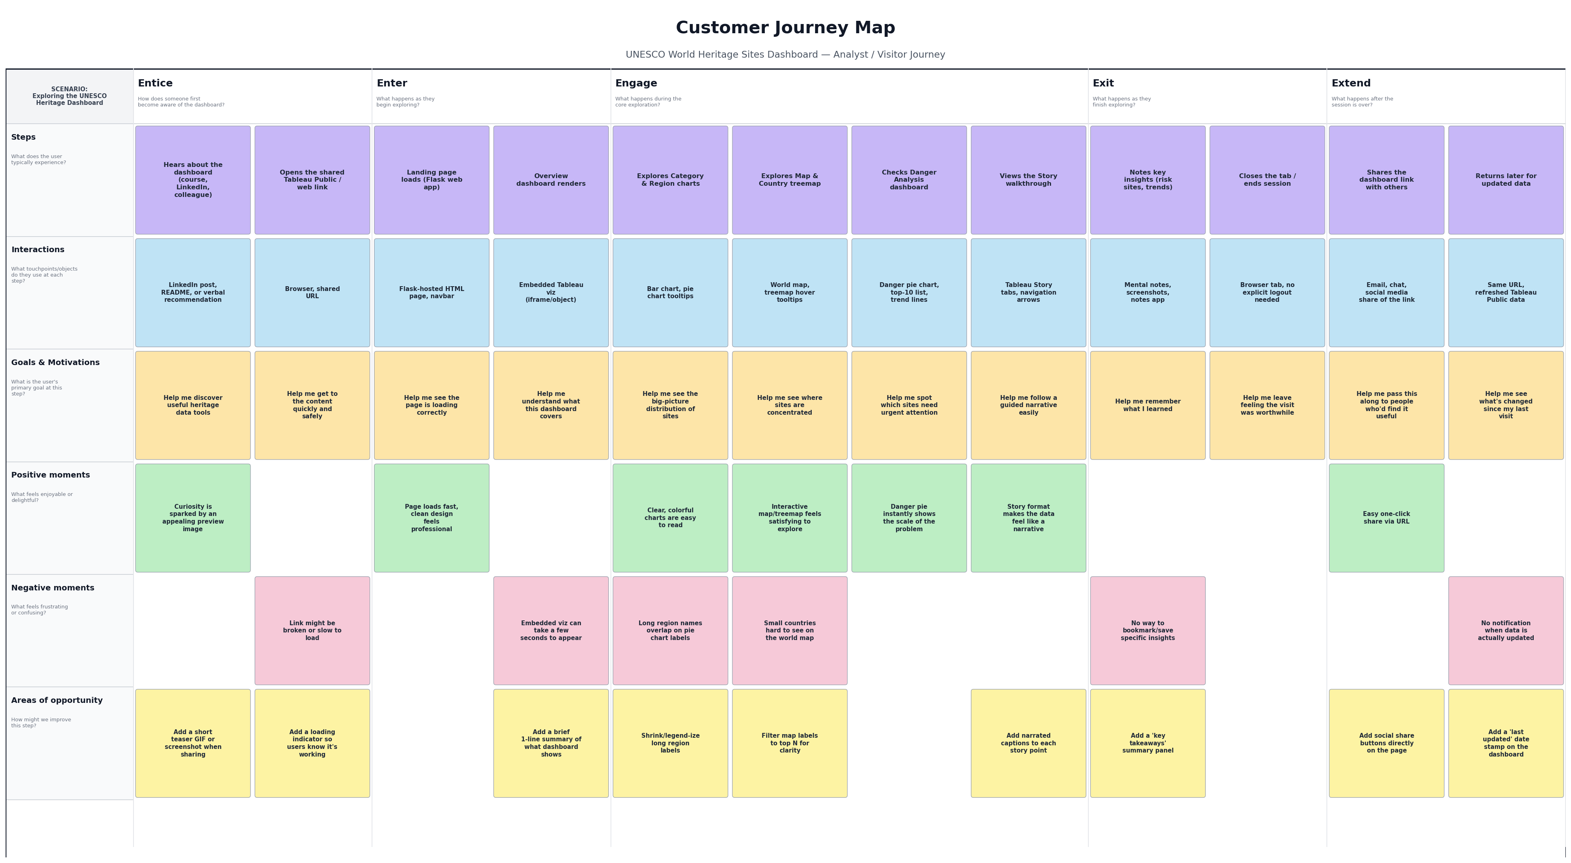
Customer Journey Map — UNESCO Heritage Dashboard

3.2 Solution Requirement
Functional Requirements:

FR No. | Functional Requirement (Epic) | Sub Requirement (Story / Sub-Task)
FR-1 | Data Ingestion & Cleaning | Import UNESCO heritage site CSV data; remove duplicates and null/invalid rows; standardize country, region and date fields
FR-2 | Site Distribution Visualization | Bar chart of sites by category (Cultural/Mixed/Natural); Pie chart of site count per region; Treemap of sites by country
FR-3 | Geographic Visualization | World map showing top 10 regions/sites by area; Tooltips showing country, region and site details on hover
FR-4 | Trend Analysis | Line chart of yearly inscriptions with Actual vs Estimate forecast; Line chart of regional inscription trends split by region
FR-5 | Risk & Danger Analysis | Pie chart of sites In Danger vs Not in Danger; List/bar of Top 10 danger-prone sites; Map of heritage-ended sites
FR-6 | Dashboard Assembly | Combine all charts into an Overview dashboard and a Danger Analysis dashboard with consistent titles, borders and layout
FR-7 | Story Narrative | Build a Tableau Story that walks a viewer through the Overview, Trends and Danger Analysis dashboards in sequence
FR-8 | Web Publishing | Publish dashboards and story to Tableau Public; generate embeddable share/embed codes for each
FR-9 | Web Application Integration | Embed published Tableau dashboards/story into a Flask web application with navigation, dark/light mode toggle

Non-functional Requirements:

Following are the non-functional requirements of the proposed solution.

FR No. | Non-Functional Requirement | Description
NFR-1 | Usability | Dashboards use clear titles, consistent color coding, tooltips, and a simple navigation bar so users can explore heritage data without training
NFR-2 | Security | Published Tableau content is read-only for public viewers; no personal or sensitive data is exposed since the dataset is public UNESCO information
NFR-3 | Reliability | Dashboards are backed by a cleaned, validated dataset with no missing critical fields, so charts render consistently every time they are loaded
NFR-4 | Performance | Dashboards and the embedded Flask page load within a few seconds on a standard broadband connection; charts render without noticeable lag when filtering
NFR-5 | Availability | Dashboards are hosted on Tableau Public (99%+ uptime) and the Flask app can be run locally or deployed, ensuring the project is accessible for demonstration at any time
NFR-6 | Scalability | The workbook structure and data model can accommodate additional years, regions, or new UNESCO sites being added without redesigning the dashboards
NFR-7 | Maintainability | Worksheets are clearly named (e.g., Heritage Sites by Country, Regional Inscription Trends) so future updates or new scenario charts can be added easily
NFR-8 | Portability | The Flask web app and embed codes work across modern browsers (Chrome, Edge, Firefox) and are responsive to different screen sizes

3.3 Data Flow Diagram
The Level-1 DFD below shows how heritage data flows from the raw UNESCO source through cleaning, Tableau analytics, publishing, and finally to end users via Tableau Public and the Flask web app.
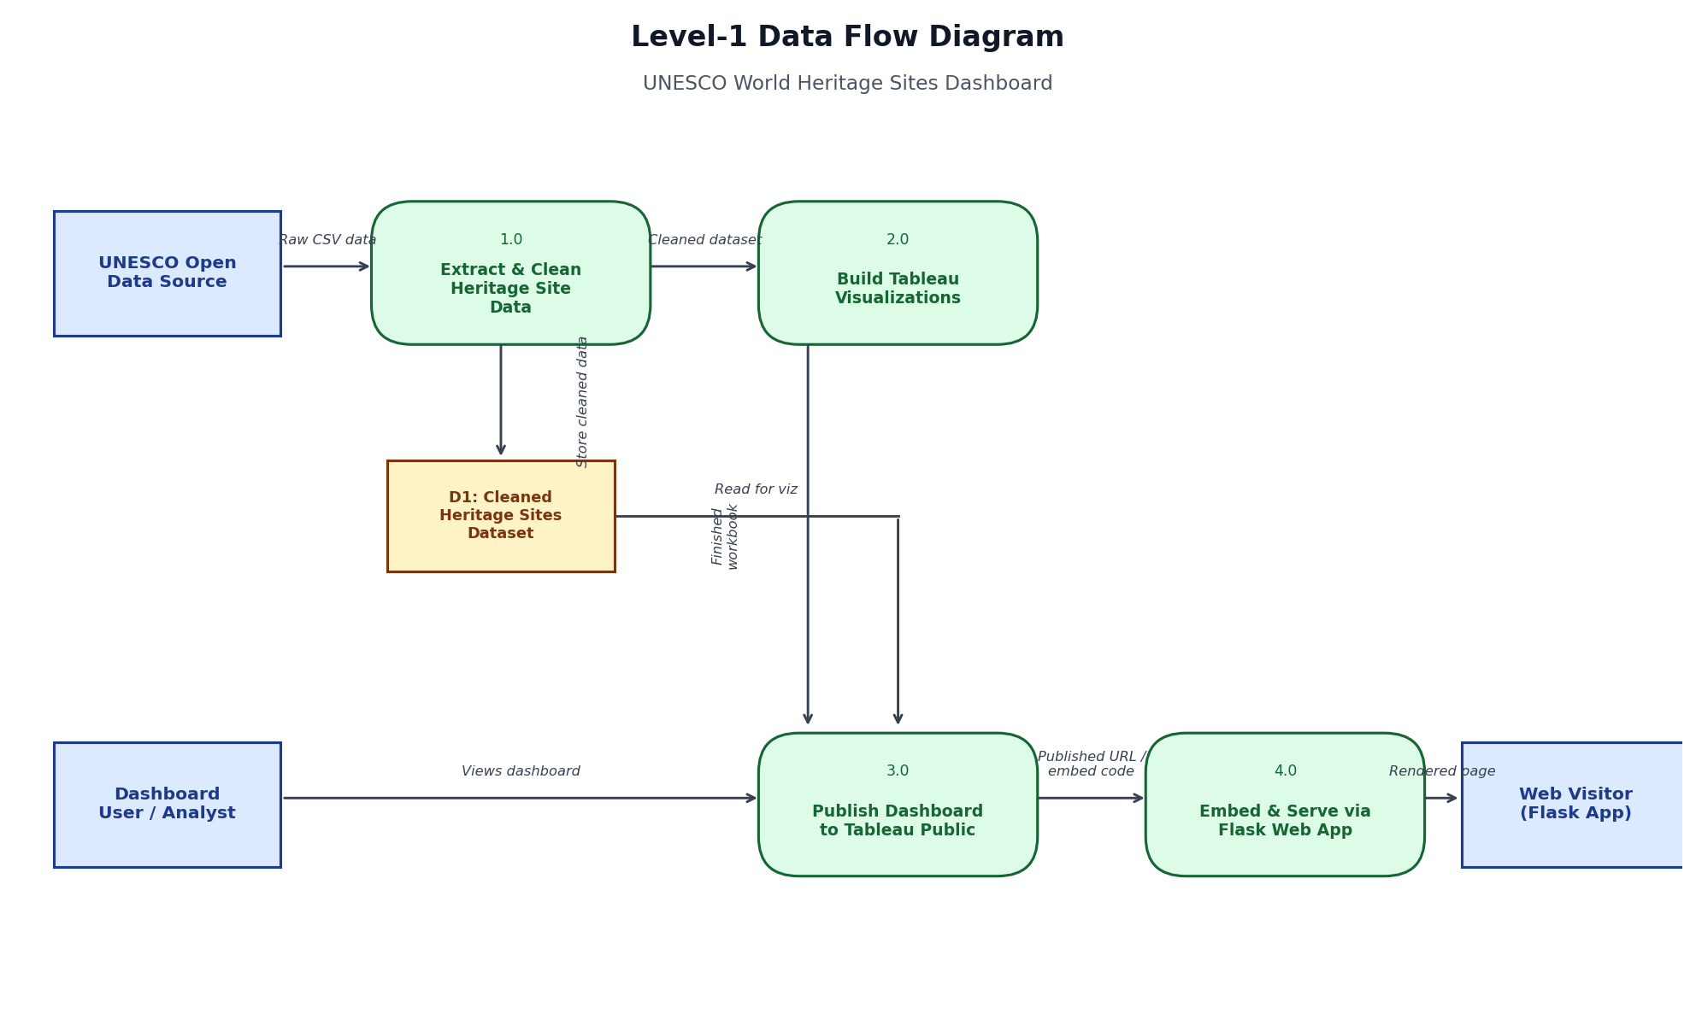 Level-1 Data Flow Diagram
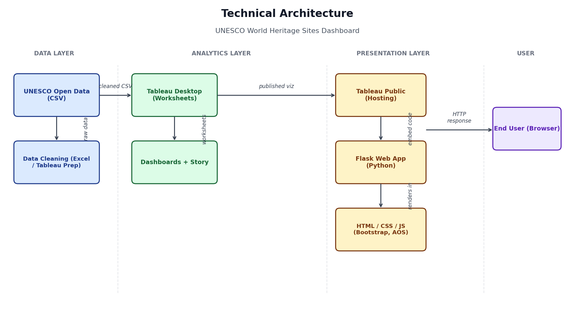 Technical Architecture — Data, Analytics, Presentation and User layers

Table-1 : Components & Technologies:

S.No | Component | Description | Technology
 | User Interface | How the user interacts with the dashboard and website | Tableau Dashboard UI, HTML, CSS, Bootstrap, JavaScript
 | Application Logic-1 | Cleans and prepares raw UNESCO site data for analysis | Excel / Tableau Data Prep
 | Application Logic-2 | Builds all chart worksheets and dashboards from the cleaned data | Tableau Desktop
 | Application Logic-3 | Serves the published dashboards inside a custom web page | Flask (Python)
 | Database | Stores the cleaned heritage sites dataset used by all worksheets | Local data extract (.hyper) / CSV
 | Cloud Database | Hosts the published interactive workbook for public access | Tableau Public Cloud
 | File Storage | Stores the dataset, images and generated Word/PDF documentation files | Local Filesystem
 | External API-1 | Provides base map tiles for the geographic visualizations | Mapbox / OpenStreetMap (via Tableau Maps)
 | External API-2 | Supplies web page styling and animation libraries | Bootstrap CDN, Animate.css, AOS.js
 | Machine Learning Model | Not applicable — the dashboard uses Tableau's built-in forecasting, not a custom ML model | Tableau built-in Forecasting (Exponential Smoothing)
 | Infrastructure (Server / Cloud) | Local Server Configuration: Flask dev server on localhost, port 1212. Cloud Server Configuration: Tableau Public cloud hosting for dashboards/story | Local machine + Tableau Public Cloud

Table-2: Application Characteristics:

S.No | Characteristics | Description | Technology
 | Open-Source Frameworks | Frameworks used to style and animate the web front-end | Bootstrap 5, Animate.css, AOS (Animate on Scroll)
 | Security Implementations | Published dashboards are read-only for public viewers; no personal or sensitive data is exposed since the dataset is public UNESCO information | Tableau Public read-only viz embedding
 | Scalable Architecture | Simple layered architecture (data -> analytics -> presentation) allows new charts, years or regions to be added without redesigning existing dashboards | Layered/3-tier architecture (Data, Analytics, Presentation)
 | Availability | Dashboards are hosted on Tableau Public's cloud infrastructure, giving high uptime independent of the local Flask server | Tableau Public Cloud Hosting
 | Performance | Pre-aggregated worksheets and Tableau's in-memory data engine keep chart rendering and filtering fast even with 1,100+ site records | Tableau Hyper Engine, browser caching via CDN-hosted libraries

4. PROJECT DESIGN

4.1 Problem Solution Fit
The Problem-Solution Fit canvas maps customer segments, constraints, jobs-to-be-done, triggers, and the proposed solution against the behaviours of the target users.

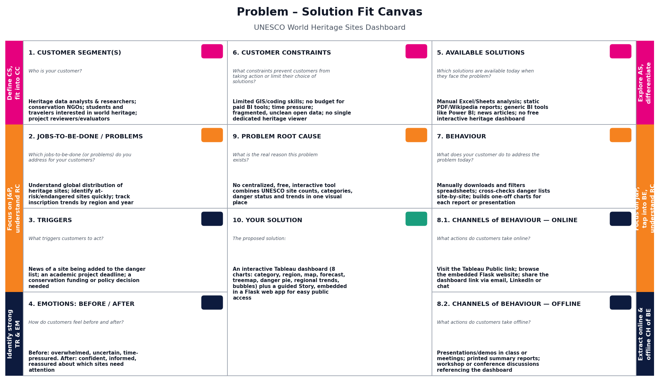
Problem – Solution Fit Canvas

4.2 Proposed Solution

S.No. | Parameter | Description
 | Problem Statement (Problem to be solved) | Data on UNESCO World Heritage Sites is scattered across spreadsheets and static reports, with no single interactive view showing site distribution, categories, regional trends, or which sites are currently in danger. This makes it hard for researchers, conservation bodies, and the public to quickly understand the state of global heritage.
 | Idea / Solution description | An interactive Tableau dashboard suite built from a cleaned UNESCO heritage sites dataset, covering 8 visualizations (category bar chart, region pie chart, world map of top sites, year-wise inscription forecast, country treemap, danger status pie chart, regional inscription trend lines, and a countries-per-region bubble chart), organized into two dashboards and a guided Story, and published via Tableau Public. The dashboards are further embedded into a custom Flask web application with navigation and a dark/light mode toggle, so anyone can explore the data without needing Tableau installed.
 | Novelty / Uniqueness | Combines site distribution, geographic, temporal, and risk/danger analysis in one connected suite rather than a single generic chart; pairs a Tableau Story with a custom-branded, publicly accessible Flask web page instead of only sharing a raw Tableau Public link; treemap and bubble views make the country/region-level scale easy to grasp at a glance.
 | Social Impact / Customer Satisfaction | Helps conservation researchers and NGOs quickly identify at-risk heritage sites so preservation efforts can be prioritized; helps students, educators, and travelers learn about world heritage through an engaging visual experience rather than dense text reports; increases public awareness of endangered cultural and natural heritage.
 | Business Model (Revenue Model) | As an educational/research and awareness project, the primary value is knowledge-sharing rather than direct revenue. Potential extensions include offering the dashboard as a white-labeled reporting tool for heritage/tourism boards, or a freemium model where the public dashboard is free while custom regional reports or API data access are offered to conservation organizations for a fee.
 | Scalability of the Solution | Built on a layered architecture (data -> Tableau analytics -> Tableau Public -> Flask web app), so new years, regions, or additional UNESCO sites can be added to the dataset without redesigning existing charts. Additional scenario dashboards (e.g., climate-risk overlays, tourism impact) can be added as new worksheets and dropped into the existing dashboard/story structure with minimal rework.

4.3 Solution Architecture
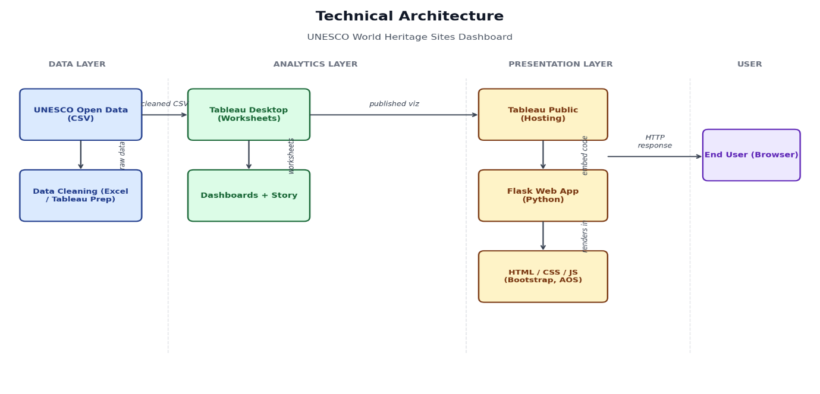
Solution Architecture — data flow from source to published web application
5. PROJECT PLANNING & SCHEDULING

5.1 Project Planning
The team followed 3 sprints. Story points were estimated using the Fibonacci scale (1, 2, 3, 5).
Sprint | Total Story Points | Duration | Sprint Start Date | Sprint End Date (Planned) | Story Points Completed (as on Planned End Date) | Sprint Release Date (Actual)
Sprint-1 | 12 | 4 Days | 01 Jul 2026 | 04 Jul 2026 | 12 | 04 Jul 2026
Sprint-2 | 17 | 4 Days | 05 Jul 2026 | 08 Jul 2026 | 17 | 08 Jul 2026
Sprint-3 | 21 | 4 Days | 09 Jul 2026 | 12 Jul 2026 | 21 | 12 Jul 2026

Velocity:

The team completed 50 story points across 3 sprints, each with a planned duration of 4 days. Velocity and average velocity per day are calculated as follows:
Velocity = Total Story Points Completed / Number of Sprints
Total Story Points = 12 + 17 + 21 = 50
Number of Sprints = 3
Velocity = 50 / 3 = 16.67 Story Points per Sprint
Average Velocity (AV) per day = Velocity / Sprint Duration = 16.67 / 4 = 4.17 Story Points per day
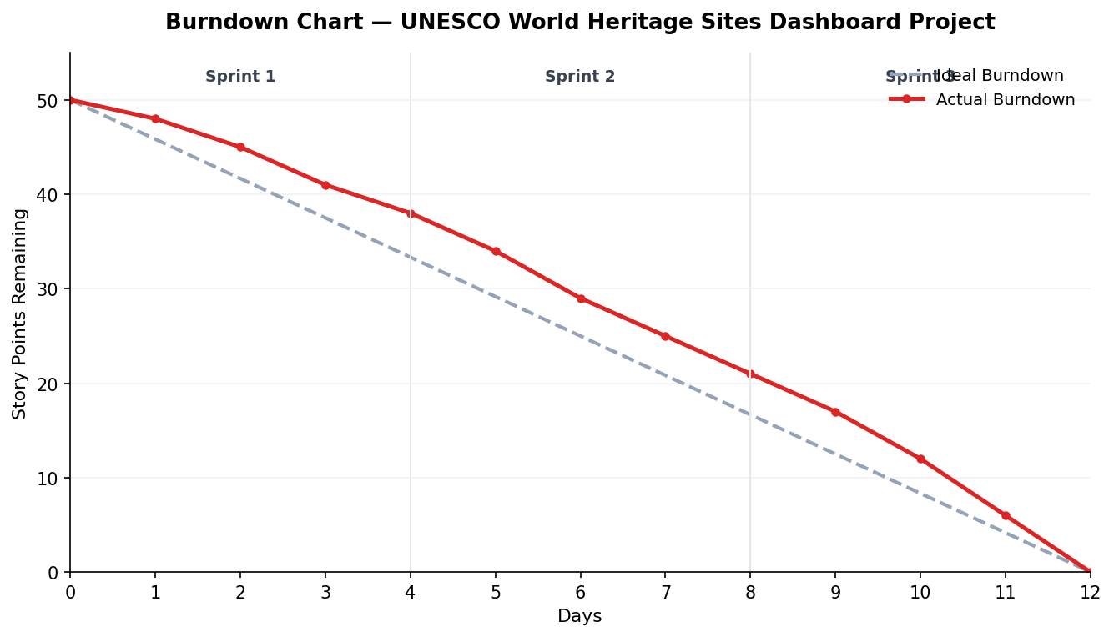
Burndown Chart — Ideal vs Actual across 3 sprints (12 days)
6. FUNCTIONAL AND PERFORMANCE TESTING

6.1 Performance Testing
S.No. | Parameter | Screenshot / Values
 | Data Rendered | Successfully imported and visualized the UNESCO World Heritage Sites dataset. The dashboard displays Cultural, Natural and Mixed heritage sites across different countries and UNESCO regions using interactive visualizations.
 | Data Preprocessing | • Cleaned missing and duplicate records.  • Standardized Region and Country names.  • Converted Date Inscribed into Year format.  • Assigned Geographic Roles for map visualization.  • Formatted Area (Hectares) and Danger Status fields.  • Created calculated fields for analytical insights.
3. | Utilization of Filters | Interactive filters were implemented to allow users to explore data dynamically.  Filters Used:  • Region  • Country  • Heritage Category  • Danger Status  • Year of Inscription
4. | Calculation fields Used | The following calculated fields were created:  • Site Count  • Distinct Countries Count  • Heritage Category Count  • Total Area (Hectares)  • Danger Sites Count  • Top 10 Regions by Area  • Forecasted Heritage Trend
5. | Dashboard design | No of Visualizations / Graphs – 11  Dashboard 1: UNESCO World Heritage Sites Overview (6 Visualizations)  - Categories by Sites Count – Bar Chart  - Site Count per Region – Pie Chart  - Top 10 Regions by Area – Filled Map  - Year Forecasting of Heritages – Forecast Line Chart  - Heritage Sites by Country – Treemap  - Countries per Region – Packed Bubble Chart  Dashboard 2: UNESCO Danger Sites Overview (5 Visualizations)  - Heritage Sites at Risk – Pie Chart  - Regions by Heritage Endangered – Filled Map  - Analysis of Danger Sites and Area of Heritages – Dual Axis (Bar + Line Chart)  - Top 10 Danger Sites Prone to Extinction – Treemap  - Regional Inscription Trends – Multi-Line Chart
6 | Story Design | No of Visualizations / Graphs -2  Story Point 1: UNESCO Site Overview  - Displays Dashboard 1 with six visualizations for global heritage analysis.  Story Point 2: UNESCO Danger Sites Overview  - Displays Dashboard 2 with five visualizations focusing on endangered heritage sites, regional trends, and conservation analysis.  Story Features:  - Navigation between two story points.  - Interactive dashboards.  - Comparative analysis of heritage distribution and endangered sites.  - Geographic and trend-based visualizations.

7. RESULTS

7.1 Output Screenshots
Visualizations:
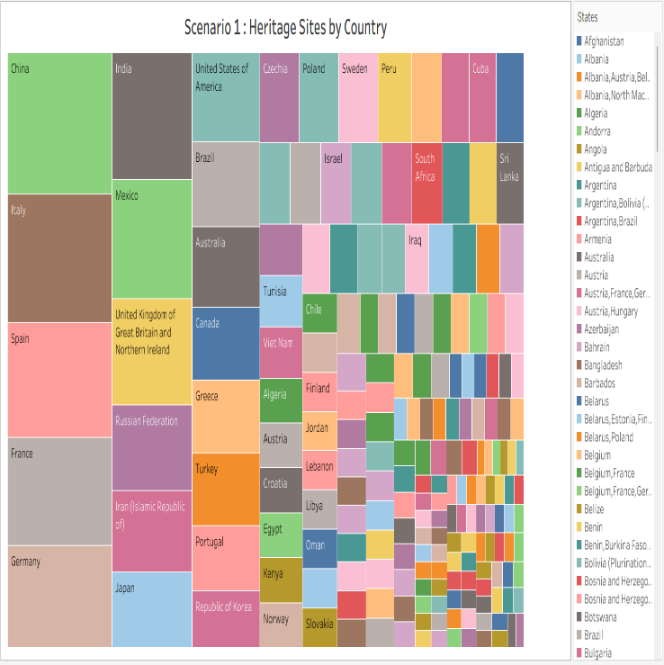
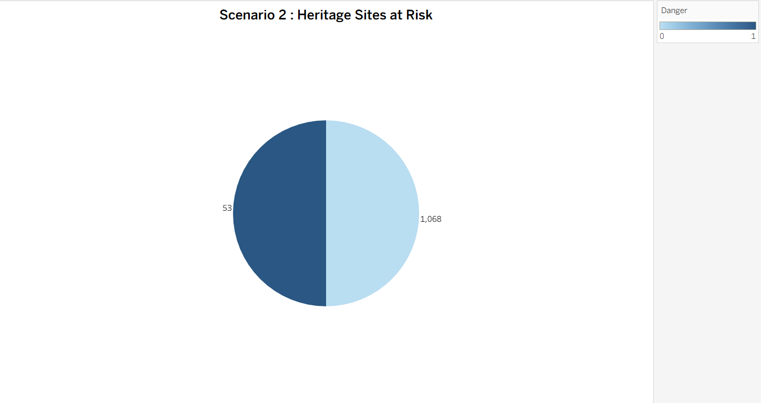

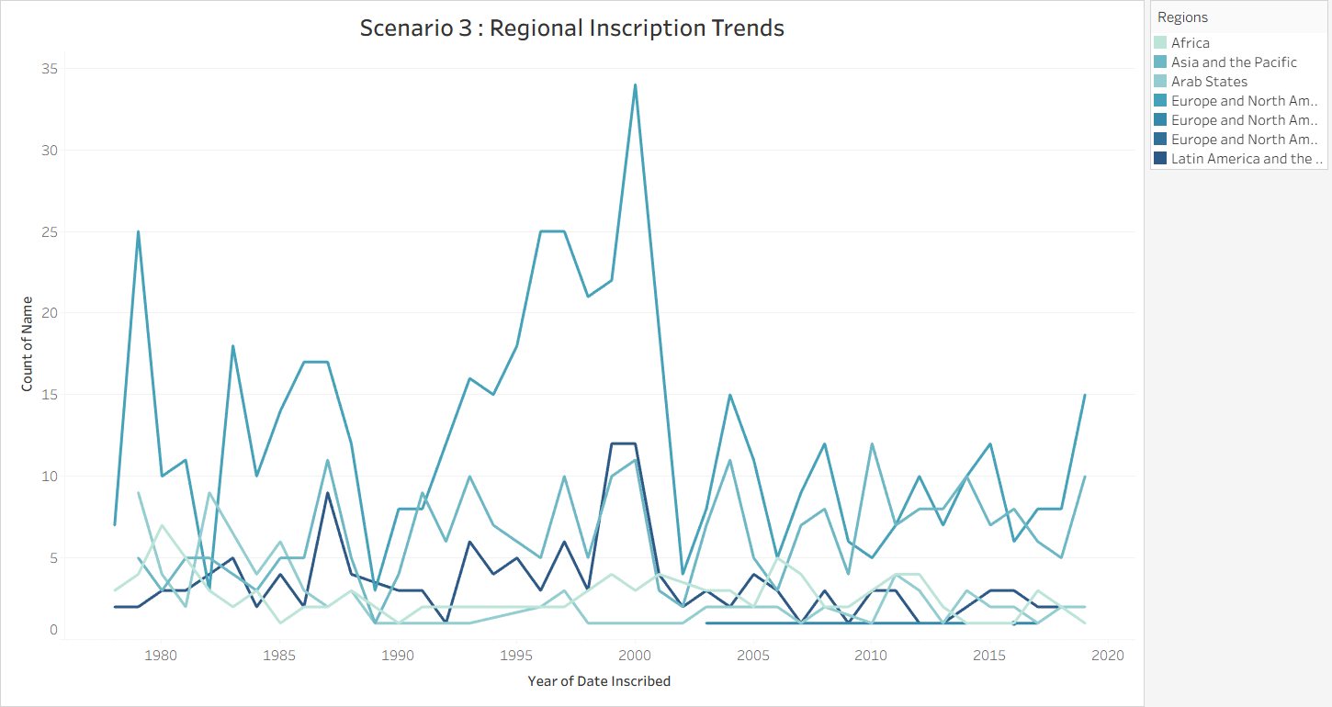
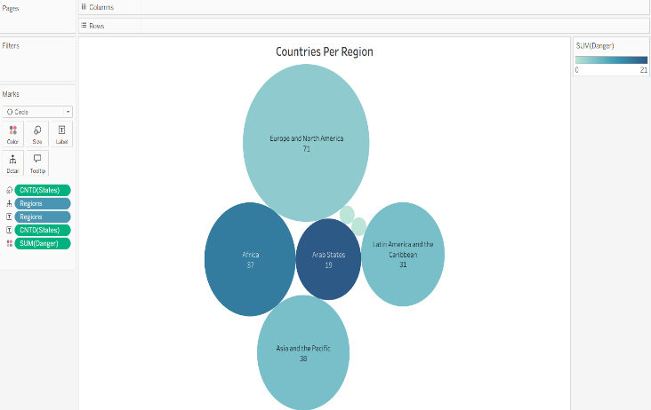
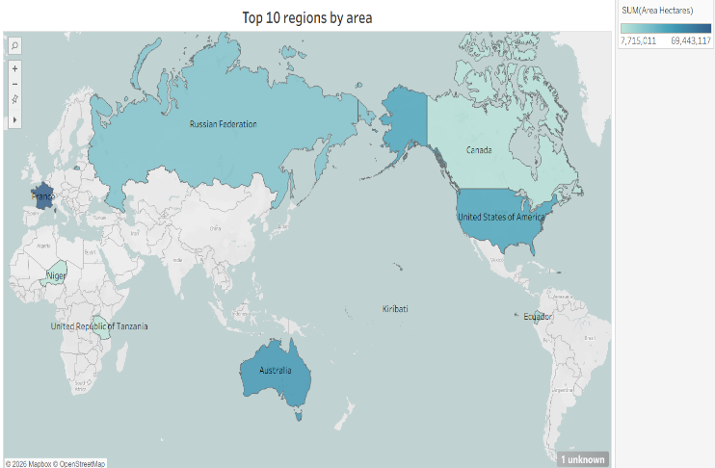
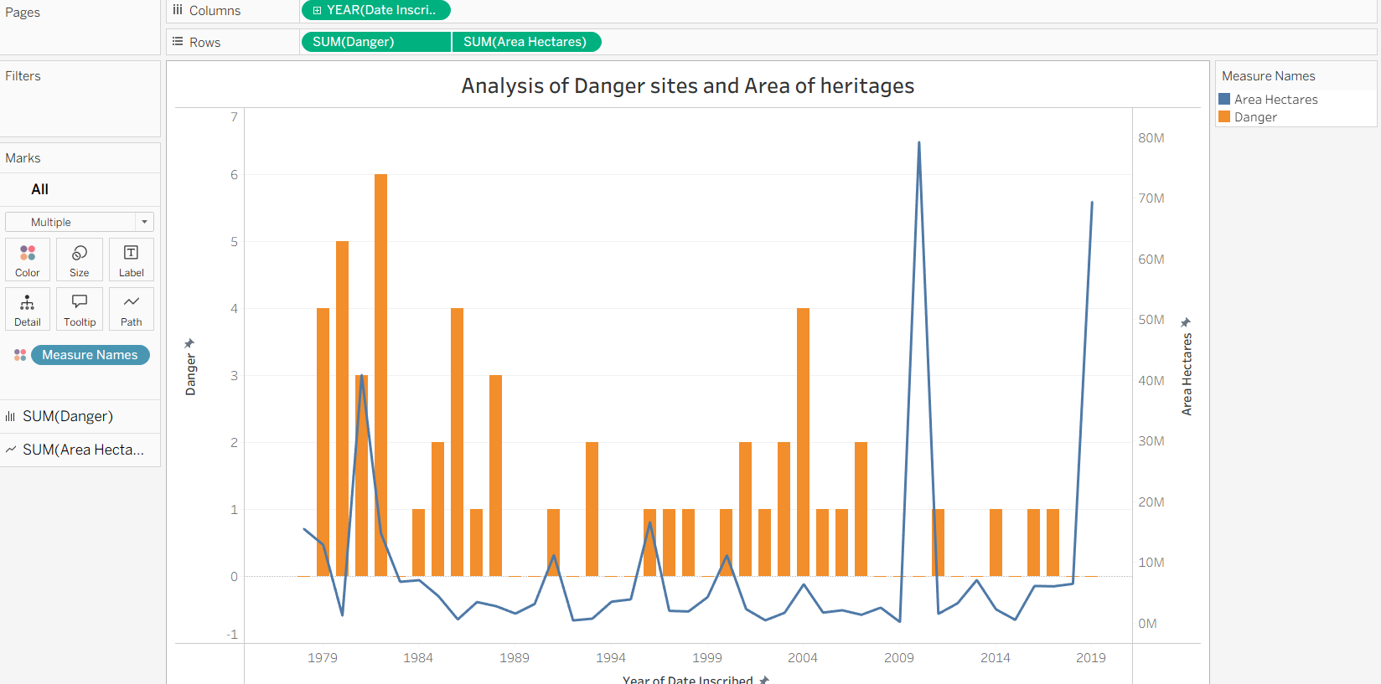
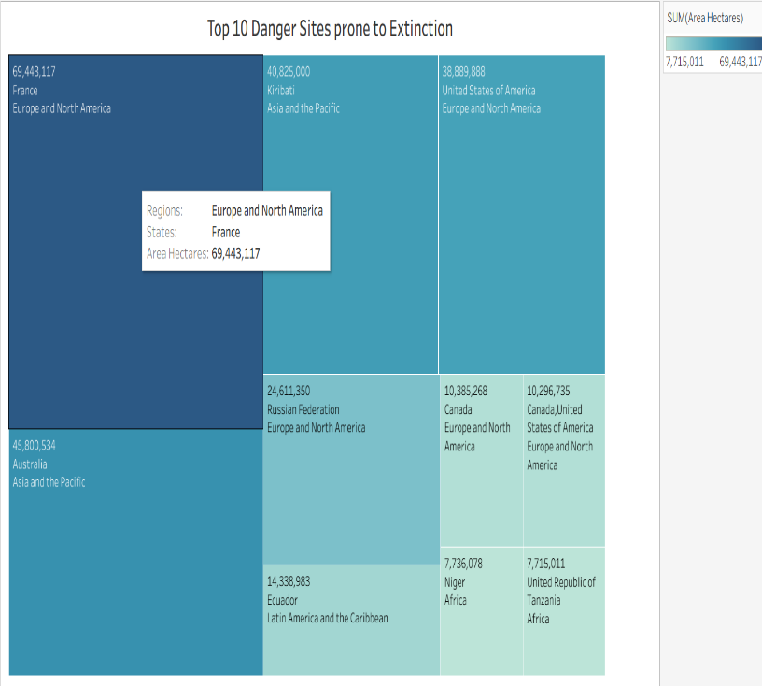
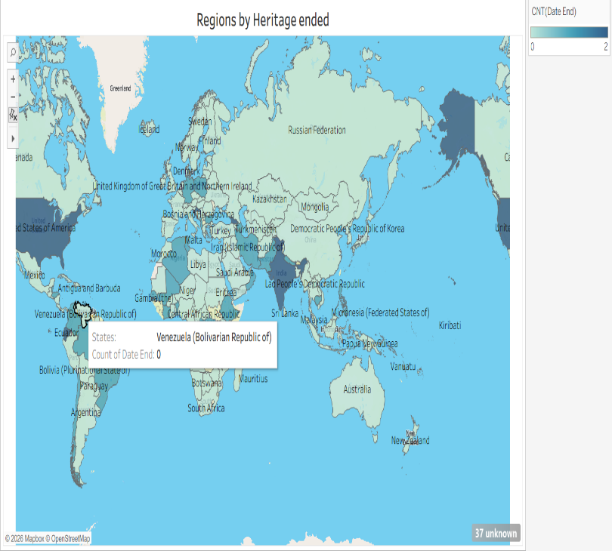
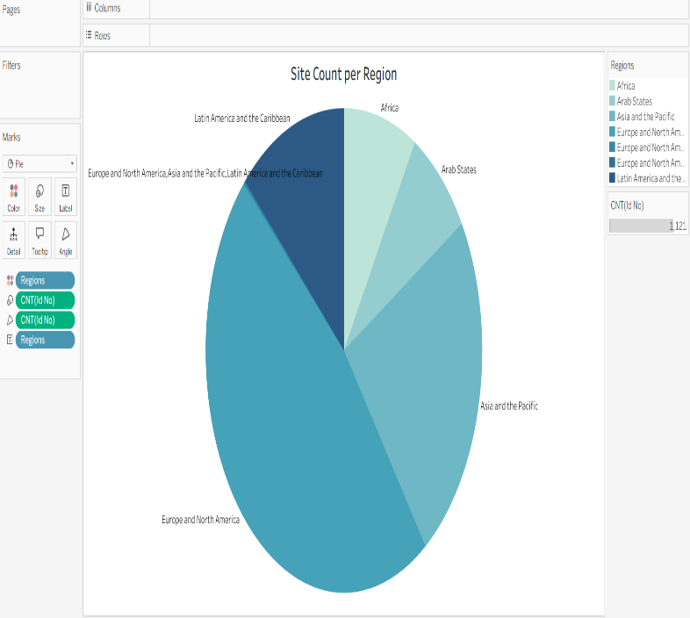
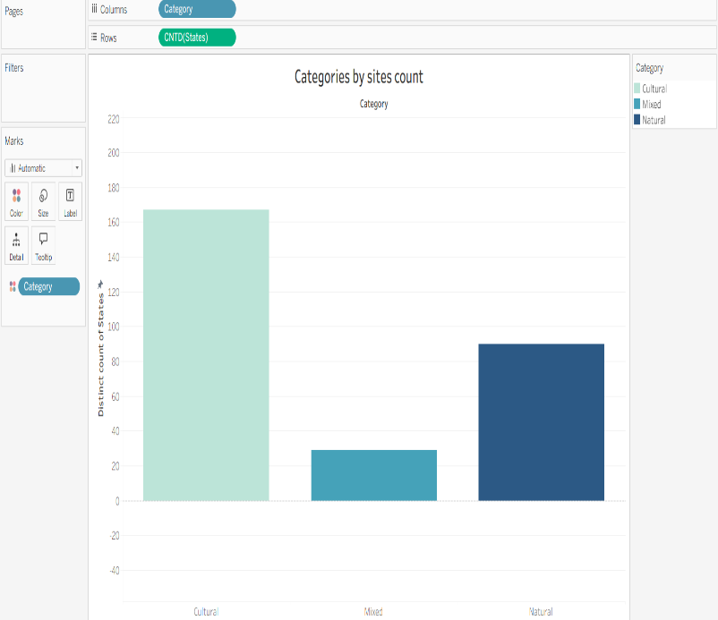
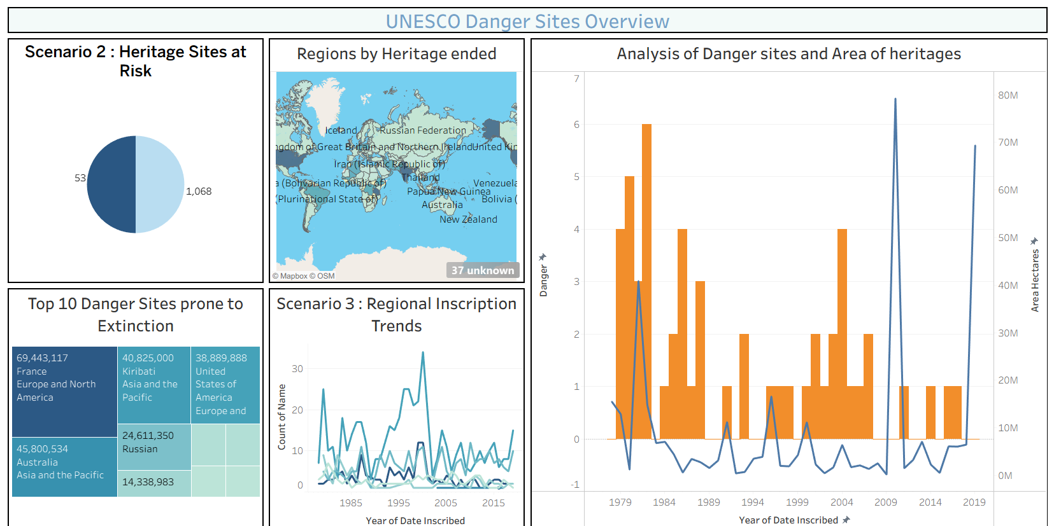
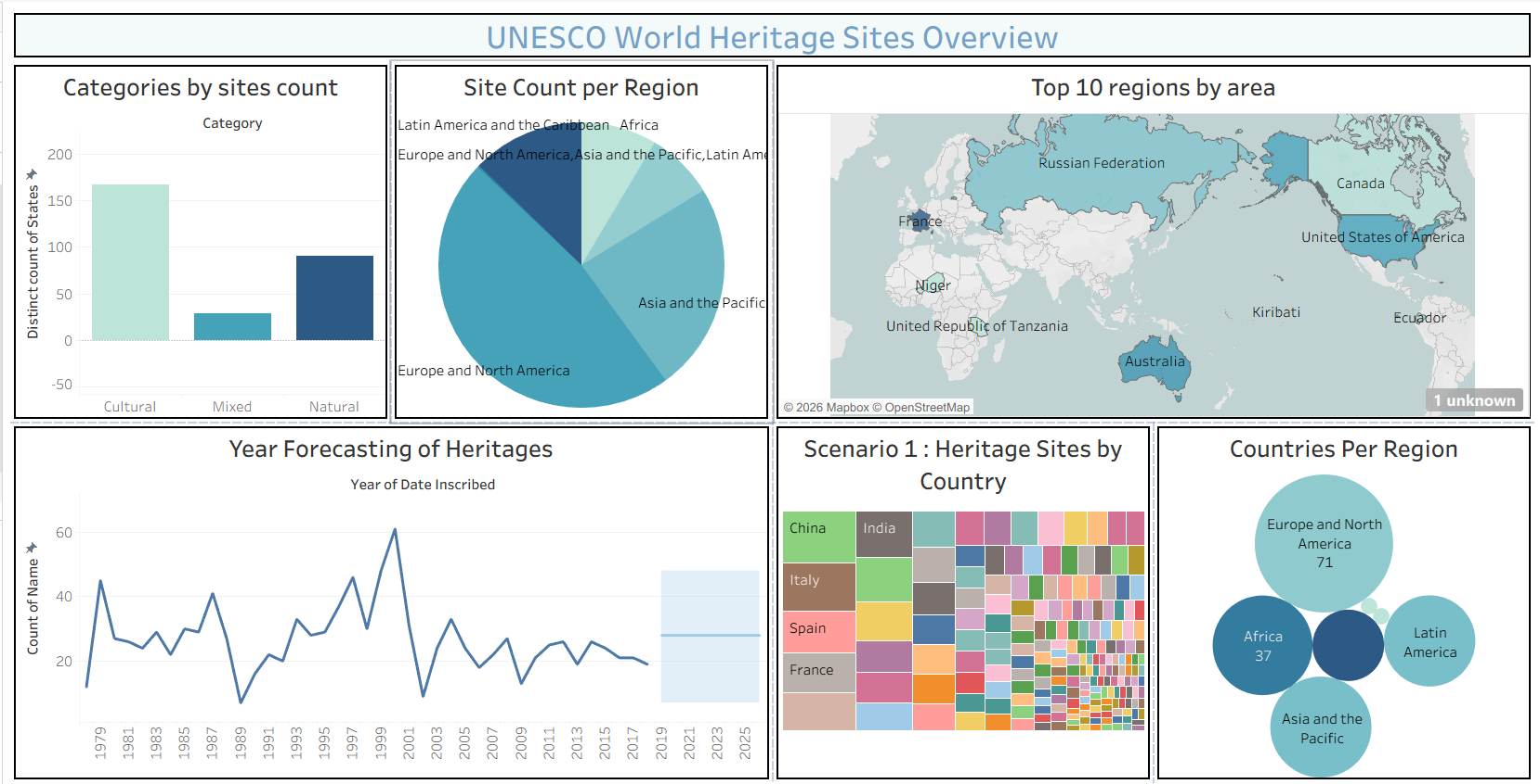
Dashboards:

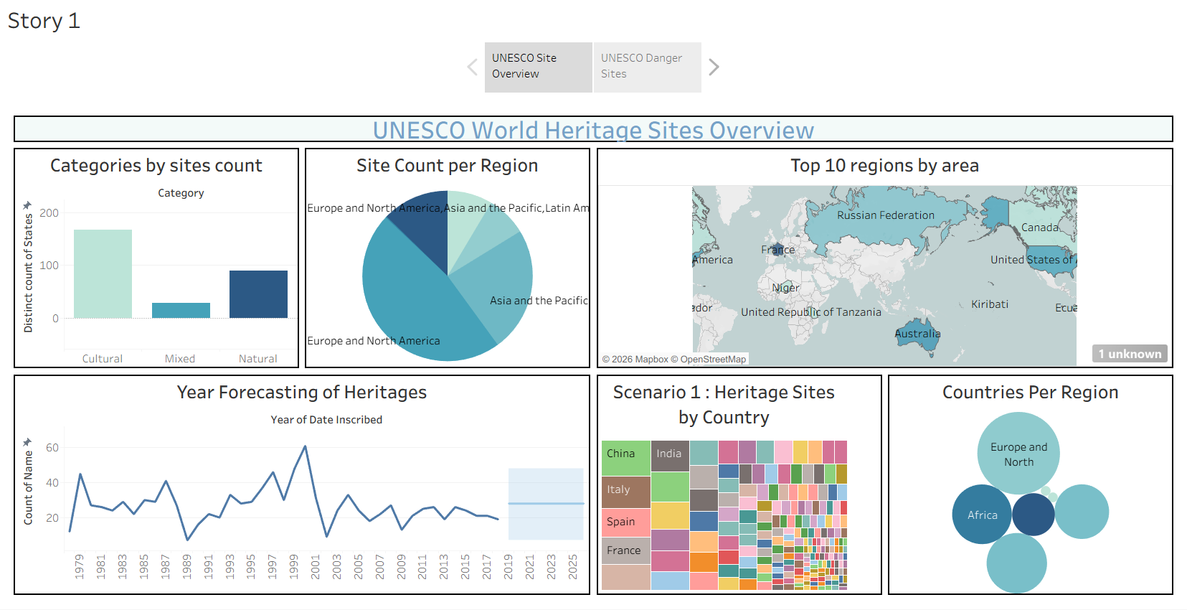
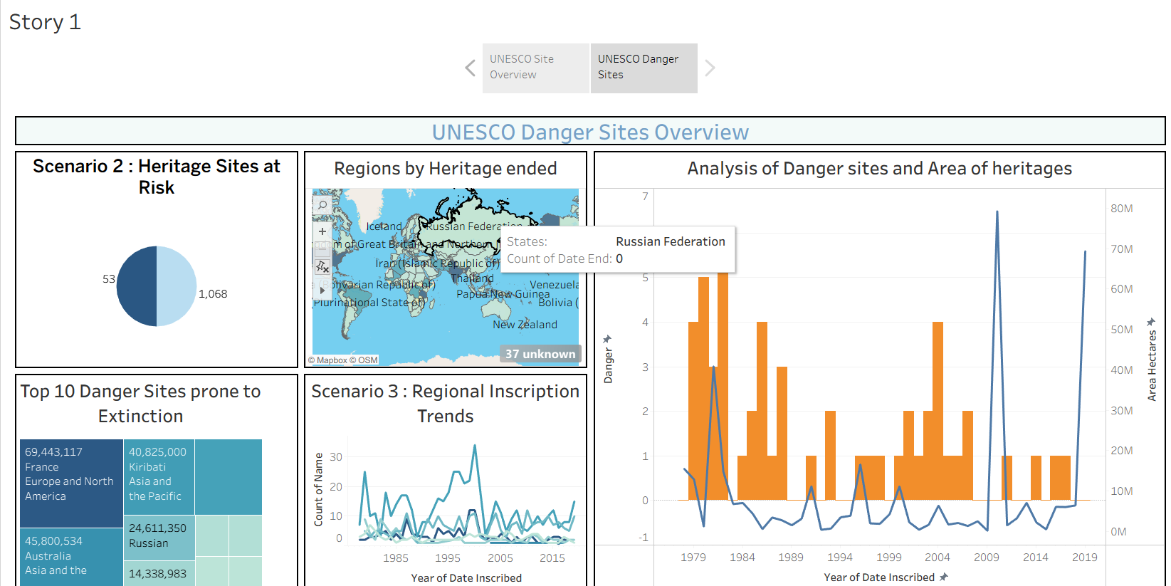
Story:

8. Advantages & Disadvantages

Advantages
- Consolidates scattered UNESCO data into one interactive, visual experience.
- Publicly accessible via Tableau Public and a custom Flask web app — no Tableau license required to view.
- Covers distribution, geography, trends and risk analysis in a single connected suite.
- Guided Story format makes the data approachable for non-technical audiences.

Disadvantages
- Relies on the completeness/accuracy of the underlying open dataset; delisted or newly added sites require manual refresh and republishing.
- Tableau Public dashboards are read-only and have data size/row limits for free accounts.
- Embedded Tableau visualizations depend on an internet connection and the Tableau Public service being available.

9. CONCLUSION
The Heritage Treasures project successfully transforms scattered UNESCO World Heritage Site data into an interactive, visually engaging dashboard suite. By combining category, regional, geographic, trend and danger-risk analysis into two connected dashboards and a guided Story — and making them publicly accessible through Tableau Public and a custom Flask web application — the project achieves its goal of helping researchers, conservationists, students and travelers explore and understand global heritage data more effectively than static spreadsheets or reports ever could.

10. FUTURE SCOPE
- Add real-time or scheduled data refresh so newly listed or delisted sites appear automatically.
- Introduce climate-risk or tourism-impact overlays as additional scenario dashboards.
- Add user accounts to let visitors bookmark or annotate specific sites of interest.
- Offer a lightweight API or downloadable regional reports for conservation organizations.
- Expand language support for the Flask web page to reach a wider global audience.

11. APPENDIX
Web Integration(source code):

Index.html

<!DOCTYPE html>
<html lang="en">
<head>
<meta charset="UTF-8" />
<meta name="viewport" content="width=device-width, initial-scale=1" />
<title>UNESCO Global Heritage Explorer</title>
<link href="https://cdn.jsdelivr.net/npm/bootstrap@5.3.3/dist/css/bootstrap.min.css" rel="stylesheet" />
<link href="https://cdnjs.cloudflare.com/ajax/libs/animate.css/4.1.1/animate.min.css" rel="stylesheet" />
<link href="https://unpkg.com/aos@2.3.1/dist/aos.css" rel="stylesheet" />
<style>
:root {
--primary-gold: #c5a059;
--deep-navy: #0f172a;
--slate-800: #1e293b;
--bg-light: #f8fafc;
--text-main: #334155;
}

body {
background: var(--bg-light);
background-image: radial-gradient(#cbd5e1 0.5px, transparent 0.5px);
background-size: 24px 24px;
color: var(--text-main);
font-family: 'Inter', system-ui, -apple-system, sans-serif;
transition: all 0.4s ease;
scroll-behavior: smooth;
}

.dark-mode {
background: var(--deep-navy);
background-image: radial-gradient(#334155 0.5px, transparent 0.5px);
color: #f1f5f9;
}

.navbar {
background: rgba(15, 23, 42, 0.9) !important;
backdrop-filter: blur(10px);
border-bottom: 1px solid var(--primary-gold);
}

.header {
text-align: center;
margin-top: 2rem;
margin-bottom: 4rem;
padding: 4rem 2rem;
background: linear-gradient(135deg, #0f172a 0%, #1e293b 100%);
color: white;
border-radius: 2rem;
border: 1px solid rgba(197, 160, 89, 0.3);
box-shadow: 0 25px 50px -12px rgba(0, 0, 0, 0.5);
}

.header h1 {
font-weight: 800;
color: var(--primary-gold);
text-transform: uppercase;
letter-spacing: -1px;
}

.tableau-card {
background: rgba(255, 255, 255, 0.9);
backdrop-filter: blur(12px);
border-radius: 1.5rem;
border: 1px solid rgba(226, 232, 240, 1);
box-shadow: 0 10px 15px -3px rgba(0, 0, 0, 0.1);
padding: 2rem;
margin-bottom: 4rem;
transition: all 0.3s ease;
}

.dark-mode .tableau-card {
background: rgba(30, 41, 59, 0.8);
border-color: rgba(197, 160, 89, 0.2);
}

.tableau-card:hover {
transform: translateY(-5px);
box-shadow: 0 20px 25px -5px rgba(0, 0, 0, 0.2);
}

.title-bar {
font-size: 1.8rem;
font-weight: 700;
margin-bottom: 2rem;
color: var(--deep-navy);
border-left: 5px solid var(--primary-gold);
padding-left: 1rem;
}

.dark-mode .title-bar { color: var(--primary-gold); }

.scroll-indicator {
position: fixed;
top: 0; left: 0; height: 5px;
background: var(--primary-gold);
z-index: 10000;
}

footer {
background: var(--deep-navy);
border-top: 2px solid var(--primary-gold);
padding: 3rem;
color: white;
margin-top: 5rem;
}
</style>
</head>
<body>
<div class="scroll-indicator" id="scrollIndicator"></div>

<nav class="navbar navbar-expand-lg sticky-top navbar-dark">
<div class="container">
<a class="navbar-brand fw-bold" href="#">UNESCO <span style="color:var(--primary-gold)">VISUALIZER</span></a>
<button class="navbar-toggler" type="button" data-bs-toggle="collapse" data-bs-target="#navbarNav">
<span class="navbar-toggler-icon"></span>
</button>
<div class="collapse navbar-collapse" id="navbarNav">
<ul class="navbar-nav ms-auto align-items-center">
<li class="nav-item"><a class="nav-link" href="#dashboard1">Overview</a></li>
<li class="nav-item"><a class="nav-link" href="#dashboard2">Danger Analysis</a></li>
<li class="nav-item"><a class="nav-link" href="#story">The Story</a></li>
<li class="nav-item"><button class="btn btn-outline-warning ms-lg-3" onclick="toggleMode()">🌓 Toggle Mode</button></li>
</ul>
</div>
</div>
</nav>

<div class="container py-4">
<div class="header animate__animated animate__fadeIn">
<h1 class="display-3">World Heritage Treasures</h1>
<p class="lead opacity-75">Visualizing the preservation of human history and natural wonder</p>
</div>

<div class="tableau-card" id="dashboard1" data-aos="fade-up">
<div class="title-bar">Site Distribution Overview</div>
<div class='tableauPlaceholder' id='viz1783755341395'>
<object class='tableauViz' style='display:none;'>
<param name='host_url' value='https%3A%2F%2Fpublic.tableau.com%2F'/>
<param name='embed_code_version' value='3'/>
<param name='name' value='UNESCOStory_17833528420560/Dashboard1'/>
<param name='toolbar' value='yes'/>
</object>
</div>
</div>

<div class="tableau-card" id="dashboard2" data-aos="fade-up">
<div class="title-bar">Vulnerability & Danger Analysis</div>
<div class='tableauPlaceholder' id='viz1783755383964'>
<object class='tableauViz' style='display:none;'>
<param name='host_url' value='https%3A%2F%2Fpublic.tableau.com%2F'/>
<param name='embed_code_version' value='3'/>
<param name='name' value='UNESCODangerSItesOverview/Dashboard2'/>
<param name='toolbar' value='yes'/>
</object>
</div>
</div>

<div class="tableau-card" id="story" data-aos="fade-up">
<div class="title-bar">UNESCO Heritage Story</div>
<div class='tableauPlaceholder' id='viz1783755497441'>
<object class='tableauViz' style='display:none;'>
<param name='host_url' value='https%3A%2F%2Fpublic.tableau.com%2F'/>
<param name='embed_code_version' value='3'/>
<param name='name' value='UNESCOStory_17833528420560/Story1'/>
<param name='toolbar' value='yes'/>
<param name='display_count' value='yes'/>
<param name='language' value='en-US'/>
</object>
</div>
</div>
</div>

<footer class="text-center">
<p class="mb-0 fw-light">Data Source: UNESCO World Heritage List</p>
<p class="small opacity-50">&copy; 2026 Digital Heritage Project | Tableau Public Integration</p>
</footer>

<script src="https://cdn.jsdelivr.net/npm/bootstrap@5.3.3/dist/js/bootstrap.bundle.min.js"></script>
<script src="https://unpkg.com/aos@2.3.1/dist/aos.js"></script>
<script>
AOS.init({ duration: 800, once: true });

const loadTableau = (id) => {
const div = document.getElementById(id);
const viz = div.getElementsByTagName('object')[0];
if (viz) {
viz.style.display = 'block';
viz.style.width = '100%';
viz.style.height = window.innerWidth < 768 ? '600px' : '850px';
const script = document.createElement('script');
script.src = 'https://public.tableau.com/javascripts/api/viz_v1.js';
viz.parentNode.insertBefore(script, viz);
}
};

window.onload = () => {
loadTableau('viz1783755341395');
loadTableau('viz1783755383964');
loadTableau('viz1783755497441');
};

function toggleMode() { document.body.classList.toggle('dark-mode'); }

window.onscroll = () => {
const winScroll = document.documentElement.scrollTop;
const height = document.documentElement.scrollHeight - document.documentElement.clientHeight;
document.getElementById("scrollIndicator").style.width = (winScroll / height) * 100 + "%";
};
</script>
</body>
</html>

app.py:

from flask import *

app = Flask(__name__)

@app.route("/")
def home():
return render_template("index.html")

if __name__ == "__main__":
app.run(debug=True, port=1212)

Dashboard 1 link: https://public.tableau.com/views/UNESCOHeritage_17833525987980/Dashboard1?:language=en-US&:sid=&:redirect=auth&:display_count=n&:origin=viz_share_link
Dashboard 2 link: https://public.tableau.com/views/UNESCODangerSItesOverview/Dashboard2?:language=en-US&:sid=&:redirect=auth&:display_count=n&:origin=viz_share_link

Story Link:
https://public.tableau.com/shared/FMDSX4T49?:display_count=n&:origin=viz_share_link

Dataset Link:
https://www.kaggle.com/datasets/ujwalkandi/unesco-world-heritage-sites/data?select=whc-sites-2019.csv

Github Link:
https://github.com/AfridM778/Heritage-Treasures-An-In-Depth-Analysis-of-UNESCO-World-Heritage-Sites-in-Tableau.git

